Name : Sakshi
Roll no: 39
Section: K22EG

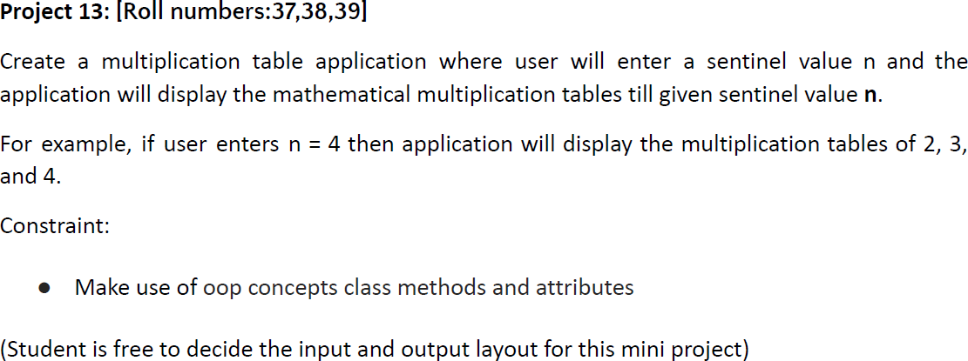

Code :

# PYTHON PROJECT
class Tables: # class Table
pass
n=Tables()
n.name=int(input("Enter the Number: ")) #Taking the input fromuser.
for j in range(2,n.name+1): # using for loop iteration.
for i in range(1,11): # using nested for loop.
print(j,"x",i,"=",j*i)
print() # Used for seprating the Tables.

